

**Summer Newsletter 5**

***Friday 7th June***

Dear Parents and Carers,

We welcome everyone back to school and hope you all had an enjoyable half term break!

**Class 2 Residential Trip Monday 10th June to Friday 14th June**



This years’ Residential Trip takes place next week at **Charterhouse Residential Education Centre** in the Mendips and will be a fantastic opportunity for the children to meet and make new friends while also taking part in activities which we cannot provide. We will be leaving from school, along with children and teachers from Stawley School, on Monday morning. **Please make sure that all children have a packed lunch for Monday.**

The deadline for payments on Parentpay has now passed. Anyone that has not paid the balance owing, please can you log on to Parentpay and make payment as soon as possible. Please speak to myself or Mrs Horne if you need assistance.



**Bags To School Collection**

Thank you to everyone who brought in their full bags. We have raised £66.40.

**Tempest School Photos**

If you would like to order through the school, then please can order envelopes be returned to Mrs Horne by next Friday, (14th June) thank you.

**Grass track Cycling**

On Tuesday 4th June, eight children from Class 2 took part in this event at Richard Huish in Taunton. Well done to Jacob, Harley, Imogen, Ella, Finnegan, George, Abbie and Georgiana who enjoyed taking part in various cycling races. Many thanks to Mrs Skinner for taking the children and the adults who helped transport the children.



**Quad kids**

On Thursday 6th June, sixteen children from Class 2 took part in an Athletics event at Bridgwater and Taunton College in Taunton. They had to take part in various activities including running, jumping and throwing. Well done to Tim, Caitlin, Harry, Rowan, Joby, Sophie, Bella, Emilia, Imogen, Jacob, Emma, Georgiana, Henry, Abbie, Finnegan and Logan. Miss Bartram and Mrs Skinner said the children were brilliantly behaved. Many thanks to them for taking the children and the adults who helped transport the children.





**Supporting Children and Young People with Dyslexia – A conference for Parents & Carers**

**9.30-12.30 on Saturday 29th June 2019 at Edgar Hall, Somerton.  £10. Reception and coffee from 9am.**

**Speakers: Sarah Melhuish and Mark Long, Lead Advisory Teachers, Somerset Learning Support Service.**

Dyslexia is a specific learning difficulty mainly affecting reading and spelling. However, it can also cause other difficulties. A person may read and write very slowly, confuse the order of letters in words, put letters the wrong way round - such as writing “b” instead of “d” - have poor or inconsistent spelling, understand information when told verbally, but have difficulty with information that’s written down, find it hard to carry out a sequence of directions, struggle with planning and organisation, be good in speech but unable to reflect knowledge in writing, have a poor short-term memory.

This conference will provide parents with the tools to support their children and young people at school and home.

To book your space please go to the Somerset Parent Carer Forum, <https://somersetparentcarerforum.org.uk> and look under Events. Once you have booked a space you will receive a confirmation email and details on how to pay the £10.

**Class 2**

Class 2 have been busy this week in their science lessons studying ‘Plant Investigation’.



**Class 1**

Staying with the plant theme, Class 1 have been very busy gardening.



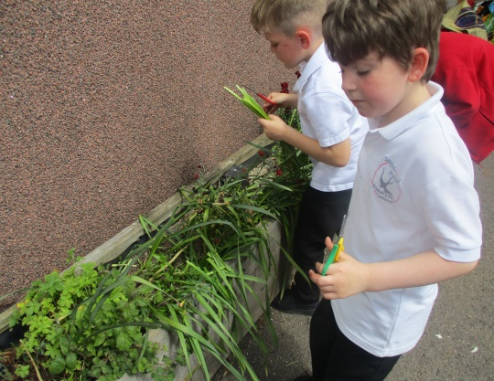

**Swimming**

There will be NO swimming on Wednesday 12th June due to class 2 being away on their Residential Trip.

**Whole School Trip** 

To tie in with topics being studied by both classes, I am very excited to let you know that this year’s whole school trip will be on Tuesday 16th July and we will be visiting Longleat.

Planning is in the early stages at the moment, but we will be aiming to leave school at around 8.45am to make our way to Longleat where we have a safari booked and a fun filled day to look forward to, with return to school expected to be 4.30pm.

As ever, we will aim to keep the cost to Parents at a minimum by subsidising some of the cost of the trip from School Funding.

I am sure this will be a wonderful way to finish the school year.

As ever, thank you for your ongoing support with all of our endeavours to make Sampford Arundel a truly community focused school and on behalf of all the staff may I wish you all a very happy half term holiday.

With very best wishes

Jacqui Collier

**FORTHCOMING EVENTS/DATES**

|  |
| --- |
| * **Sex Ed Meeting :** Friday 7th June Class 2 parents 3.30pm |
| * **Class 2 Residential :** Monday 10th June to Friday 14th June Charterhouse |
| * **FOSAS meeting :** Tuesday 11th June - Allsorts Room |
| * **Donkey Sanctuary Visit :** Wednesday 19th June |
| * **Come & have a go Athletics :** Thursday 20th June Yr 1 & 2 Bridgwater & Taunton College (SCAT) 3.50pm to 5.30pm |
| * **Guitar Performance :** Thursday 20th June 1.30pm in class2 |
| * **Cross Country :** Monday 24th June Kings College 4.15pm |
| * **Courtfields Visit :** Tuesday 2nd July - year 6 |
| * **Courtfields Visit :** Wednesday 3rd July – year 6 |
| * **Dress Rehearsal :** Monday 8th July 2.00pm |
| * **KS2 Performance :** Tuesday 9th July 6.00pm at School |
| * **KS2 Performance :** Wednesday 10th July 2.00pm & 6.00pm at School |
| * **Sampford Arundel Fete :** Saturday 13th July 2.00pm to 4.30pm |
| * **Whole School Trip :** Tuesday 16th July - Longleat |
| * **Sports Day :** Thursday 18th July School Field 5.00pm |
| * **Last day of term :** Friday 19th July |
| * **INSET DAY :** Monday 22nd July |
| * **INSET DAY :** Tuesday 23rd July |
| * **INSET DAY :** Monday 2nd September |
| * **Children return to school for New Academic Year :** Tuesday 3rd September |
| * **Half Term commences at 3.15pm :** Thursday 24th October |
| * **INSET DAY :** Friday 25th October |
| * **Children return to school :** Monday 4th November |
| * **End of Term commences at 3.15pm :** Friday 20th December |
| * **INSET DAY:** Monday 6th January 2020 |
| * **INSET DAY:** Friday 26th June 2020 |
| * **INSET DAY :** Monday 20th July 2020 |