Wellington Area Rural Federation


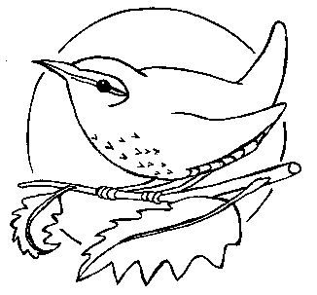

Stawley Primary School

Administering Medicines Policy
(Including forms to be completed by parents)
Status: | STATUTORY
Responsible person: | HEADTEACHER
Responsible Governor : | CHAIR OF GOVERNORS
Ratified by the Head Teacher: | September 2023
Date first approved by the Governing Body: | September 2020
Review Period: | Triennially
Review Date: | September 2026

Policy statement

Children with medical needs have the same rights of admission to school as other children. Most children will at some time have short-term medical needs, perhaps entailing finishing a course of medicine such as antibiotics. Some children however, have longer term medical needs and may require medicines on a long-term basis to keep them well. Other children may require medicines in particular circumstances, such as children with severe allergies who may need an adrenaline injection. (Managing Medicines in Schools and Early Years Settings, DfES, Update 2020)

It is important to note that: Parents have the prime responsibility for their child’s health and should provide schools with information about their child’s medical condition.

While it is not our policy to care for sick children, who should be at home until they are well enough to return to the school, we will agree to administer medication as part of maintaining their health and well-being or when they are recovering from an illness. There is no legal duty that requires school staff to administer medicines.

Procedures for prescribed medication
- A parental agreement form must be filled in by the parent of the child (Only one person with ‘parental responsibility’ needs to sign the form).
- Children taking prescribed medication must be well enough to attend the school.
- Medicine must be provided in the original container and include the prescriber’s instructions for administration.
- Medicine must be in-date and prescribed for the current condition.
- On each occasion that medicine is administered the member of staff who administers it records the time of administration in the record book/folder located in the staffroom. The parents will be informed at the end of the school day when medicine has been administered.
- Children must not self-administer medicine unless it is part of a child’s individual Health Care Plan.

Non Prescribed drugs
School staff will only administer non-prescribed medicines (e.g. Calpol) where parents have brought in the medicine and completed and signed a consent form. This is not a service that the school is obliged to undertake. It is advisable that parents seek the guidance of a Health Care Professional before asking the school to administer non-prescribed medication. The procedures for prescribed medicines will be followed for administering medicine. School staff will only administer medicines containing aspirin or ibuprofen if they have been prescribed by a doctor. (KCSIE 2019)

Storage of medicines
- All medication is stored safely in a locked cupboard in the First Aid Room or, if required, kept in an airtight container in the refrigerator in the staffroom. All medicines should be clearly named.
- For some conditions, medication may be kept in the school. Key persons check that any medication held to administer on an as and when required basis, or on a regular basis, is in date and returns any out-of-date medication back to the parent.
- If the administration of prescribed medication requires medical knowledge, individual training will be provided for the relevant member of staff by a health professional.

Children who have long term medical conditions
- A risk assessment is carried out for each child with long term medical conditions that require ongoing medication. This is the responsibility of the manager alongside the key person. Other medical or social care personnel may need to be involved in the risk assessment.
- Parents will also contribute to a risk assessment. They should be shown around the setting, understand the routines and activities and point out anything which they think may be a risk factor for their child.
- For some medical conditions key staff will need to have training in a basic understanding of the condition as well as how the medication is to be administered correctly. The training needs for staff is part of the risk assessment.
- The risk assessment includes vigorous activities and any other nursery activity that may give cause for concern regarding an individual child’s health needs.
- The risk assessment includes arrangements for taking medicines on outings and the child’s GP’s advice is sought if necessary where there are concerns.
- A health care plan for the child is drawn up with the parent; outlining the key person’s role and what information must be shared with other staff who care for the child.
- The health care plan should include the measures to be taken in an emergency.
- The health care plan is reviewed every six months or more if necessary. This includes reviewing the medication, e.g. changes to the medication or the dosage, any side effects noted etc.
- Parents receive a copy of the health care plan and each contributor, including the parent, signs it.

Managing medicines on trips and outings
- If medicine is needed to be administered whilst on a trip the trip leader will make sure that the aforementioned procedures are followed. If, due to the circumstances of the trip, there needs to be a change in the working procedures this will be discussed with the parent beforehand.
- Where medication is taken on a trip it is to be clearly labelled with the child’s name and name of the medication.
- Staff supervising trips and outings should always be aware of any medical needs and relevant emergency procedures.
- If a child has a health care plan, this will be taken on any visits in the event of the information being needed in an emergency.
- Children with reliever inhalers must take them on all trips and outings. If the child is too young or immature to take personal responsibility for their inhaler, staff need to carry the inhaler making sure it is readily accessible and clearly marked with the child’s name.

Refusal of Medicine
If a child refuses to take medicine, we will not force them to do so, but will note this in the records and contact the adult named on the medicine record form.

Asthma
Children with asthma should participate in all aspects of the school day including physical activities.
- If a child needs an inhaler for asthma, parents should complete ‘An Asthma School Card’ and discuss any requirements with staff. This includes details such as:
  - the type of medicine
  - symptoms of the child
  - whether the child needs support taking medicines
  - expiry dates of medicines
  - contact details
  - what to do in an emergency
- Children who are able to use inhalers themselves will be allowed to carry them with them.
- If the child is too young or immature to take personal responsibility for their inhaler, staff will make sure that it is stored in a safe but readily accessible place, and clearly marked with the child’s name.

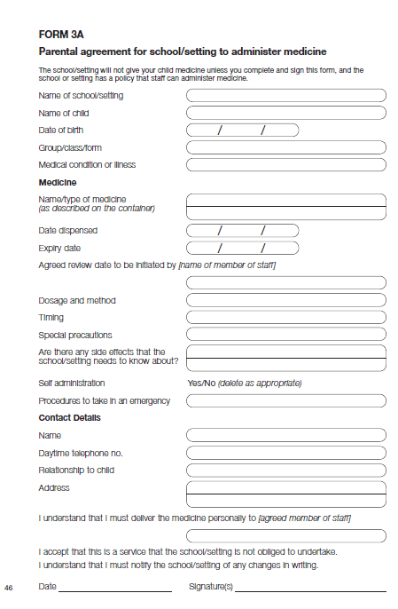

Stawley Primary School
Record of Medicines Administered to All Children
Date | Child’s Name | Time | Medicine | Dose Given | Any Reactions | Signature of staff | Print Name | Parent signature



